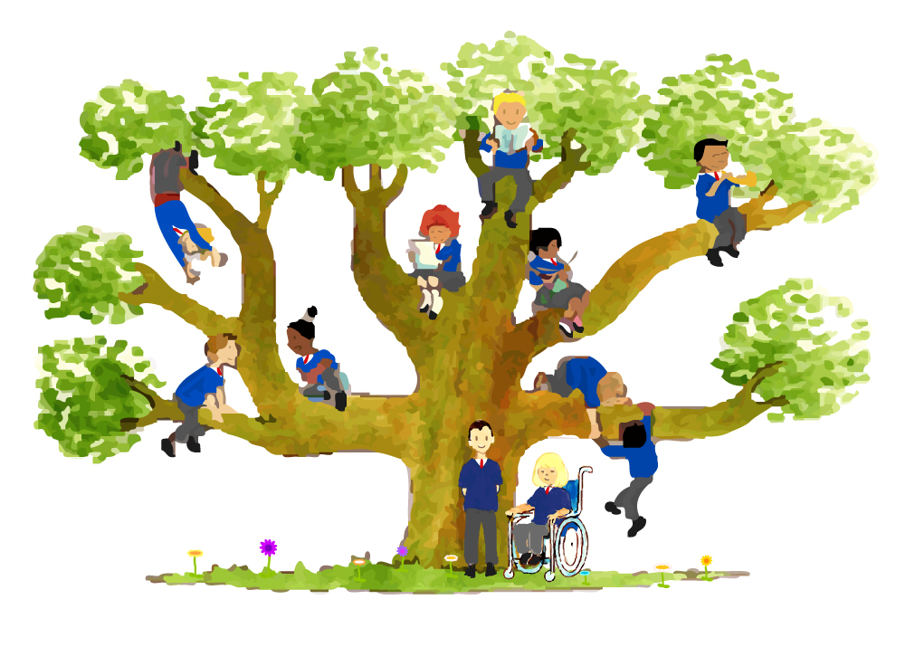

Saint Thomas More Catholic Primary School



Nursery Admission Application Form
Learn and Grow
as God's
Holy People
September/January/or Easter Admission point:_______________Year___________

Name of child for whom admission is being sought:

……………………………………………………………………………………………….. Male/Female ………………………………………………. Date of Birth

Is the child adopted? Yes/No
Has the child ever been fostered? Yes/No
Has the child ever been in the care of the Local Authority? Yes/No
Has the child accessed 2 year old funding? Yes/No

Religion…………………………………………………………………………………………….. Language ………………………………………………………………

Nationality ……………………………………………………………………………….. Ethnicity ……………………………………………………………….

Place of Baptism ………………………………………………………………….. Date of Baptism…………………………………………………
*Please note, this application cannot be processed until the original Birth Certificate and Baptismal Certificate (for any child who is Baptised Catholic) are submitted to the school.

Names of brother/sister already attending Saint Thomas More Catholic School:

……………………………………………………………………………………………………….…………………………..Class………………………………………………………………..

Give the names, addresses and contact numbers of any previous preschool or nursery your child attended or currently attends:
………………………………………………………………………………………………………………………………………………………………………………………………………………………
Mother’s details | Father’s details
Mother’s first name…………………………………………………..…..  Mother’s surname…………………………………………….……...…….  Religion………………………………………………………………..……..…………  Address…………………………………………………………………….…………..  …………………………………………………………………………………………………….  Postcode………………………………………………………………………….………  Home Telephone number…………………………………………….  Mobile number…………………………………………………………………..  Email…………………………………………………………………………………………….. | Father’s first name………………………………..……………………………..  Father’s surname………………………………………………………………….  Religion…………………………………………………………………………….…………  Address……………………………………………………….……………………………..  ………………………………………………………………………………………….…………….  Postcode…………………………………………………………………………..…………  Home Telephone number………………………………………………….  Mobile number………………………………………………………………..……..  Email……………………………………………………………………………………………..
A limited number all day places are available for parents eligible for 30-hour funding, with a 30-hour code. It is expected that children attend all five sessions Monday to Friday. It is the parent’s responsibility to provide evidence of the code to the school (this code must be renewed every three months). Failure to provide the school with an eligible code will result in the 30-hour provision being withdrawn and the hours will revert to the universal 15 hours.
More information can be found at: 30 hours free childcare - GOV.UK (www.gov.uk)
All-day children will be required to bring a packed lunch with them, or you can purchase a school meal for £2.30 per day, £11.00 per week which will be payable via Arbor.

Please indicate your preferred session:
(It is expected that children attend all five sessions Monday to Friday)

Morning: 8.30am –11.30am
Afternoon:12.20pm – 3.20pm
All Day: 8.30am – 3.20pm *£5.50 daily fee

*All Day 30 hours funding is from 8.30am-2.30pm. Teaching continues until 3.20pm with the additional 50 minutes incurring a fee of £5.50 to cover staffing costs.

Please give details of any particular needs your child has………………………………………………………………………………..…

……………………………………………………………………………………………………………………………………………………………………………………………………………..………

………………………………………………………………………………………………………………………………………………………………………………………………………………….….

We will try to accommodate your wishes; however, it must be understood that we cannot guarantee that you will be offered the sessions you have requested.
You will be informed of the decision after February half-term. The deadline for applications is 15th January, any applications received after this date will go into the second round of allocation.

If your application is successful, you will receive information about Nursery starting dates and information evenings during the summer term.

Admission into Nursery does not guarantee a place in Reception at Saint Thomas More Catholic Primary School.
You must make a new application, against a different criteria for admission, to the Reception year of Saint Thomas More Catholic Primary School. Please read the Admissions policy on our website: Admissions (stmschool.co.uk)

Signature of parent/guardian:………………………………………………………………………………………………………
Date of application:……………………………………………………………………………………

Office use only
Date Received: | Birth Certificate? | Baptismal Certificate?

